**OBJECTIVE**

The principal objective of this study is

**Automatic Bangla Digital Number Plate Detection & Recognition System using Image Processing & Deep Learning**

Noshin Faria, Plabon Banik , Amit Majumder, Adri Saha

Department of Computer Science & Engineering, East West University

**EXPERIMENTAL RESULT IMPLEMENTATION OF WEBSITE**

**Table 1**: Experimental Results of Number Plate Detection

• to propose a system that can detect and extract a number plate from an image,

• localize characters, segment them from a number plate, and • Finally, recognize those characters to collect the license plate’s number.

**METHODOLOGY**

| **Model Name** | **Accuracy** | **Precision** | **Recall** | **mAP@.5** | **mAP@0.5:0.95:** |
| --- | --- | --- | --- | --- | --- |
| YOLO V7 | 0.91 | 0.994 | 0.901 | 0.938 | 0.827 |
| Image Processing Techniques | – | 0.936 | 0.915 | – | – |

**Table 2:** Experimental Results of Character Localization **Table 3**: Experimental Results of Character Localization

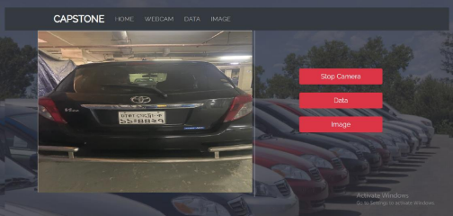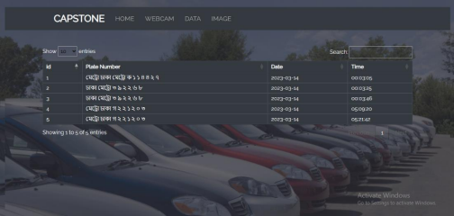**Used Technologies :**

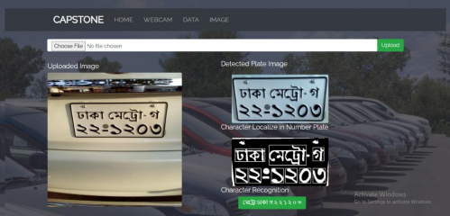

| **Method** | **Accuracy (%)** |
| --- | --- |
| YOLO V7 | 91.38% |
| Others(using same  dataset) | 89.10% |

| **Precision** | **Recall** |
| --- | --- |
| 0.85 | 0.97 |



**Figure 01:** Workflow Diagram

**Supervised By**

**Table 4:** Experimental Results of Character Localization

| **Model Name** | **Loss** | **Accuracy** | **Precision** | **Recall** |
| --- | --- | --- | --- | --- |
| Inception | 0.3522 | 0.8696 | 0.8807 | 0.8587 |
| VGG16 | 0.5226 | 0.9157 | 0.9187 | 0.8413 |
| VGG19 | 0.5379 | **0.9369** | 0.9127 | **0.9476** |
| Xception | 0.3726 | 0.9026 | **0.9539** | 0.8261 |
| DenseNet | **0.3254** | 0.8985 | 0.8994 | 0.8565 |
| Inception | 0.3574 | 0.8312 | 0.8801 | 0.8220 |

**Figure 04:** Confusion Matrix of YOLO V7 model **Figure 05:** Precision recall curve of YOLO

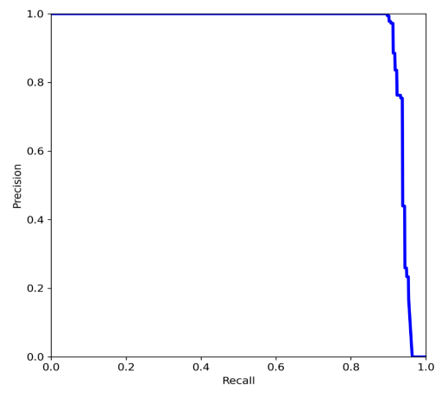

V7

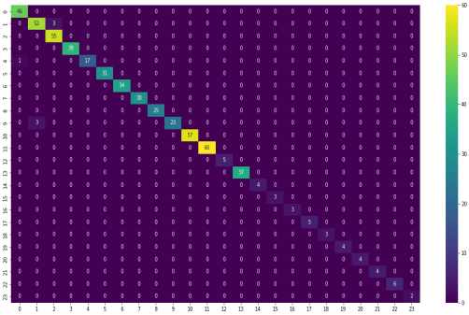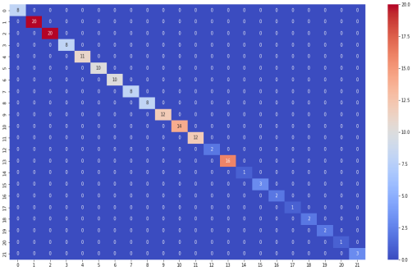**Figure 06:** Confusion Matrix of VGG19 in train & test phase

**References**

**EARN VALUE MANAGEMENT**

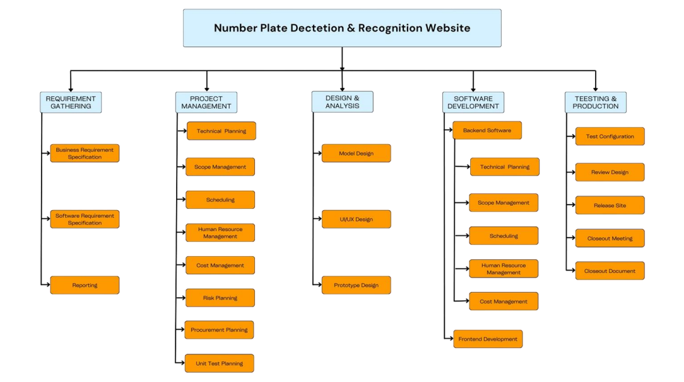**Figure 07:** Work Breakdown Structure (WBS)

**COST CALCULATION & EARNED VALUE DIAGRAM** 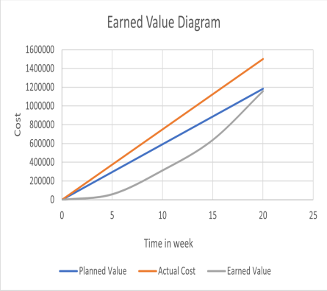

Dr. Md. Nawab Yousuf Ali

Professor

Department of Computer Science and Engineering East West University

- Islam, R., Islam, M.R. and Talukder, K.H., 2020. An efficient method for extraction and recognition of bangla characters from vehicle license plates. *Multimedia Tools and Applications*, *79*(27), pp.20107- 20132

- Chandra, S., Nowshad, M.A.A. and Islam, M.J., 2017, December. An automated system to detect and recognize vehicle license plates of Bangladesh. In *2017 20th International Conference of Computer and Information Technology (ICCIT)* (pp. 1-6). IEEE.

- Shaifur Rahman, M.M., Shamima Nasrin, M., Mostakim, M. and Zahangir Alom, M., 2018. Bangla License Plate Recognition Using Convolutional Neural Networks (CNN). *arXiv e-prints*, pp.arXiv-1809. - Islam, M.A., Chowdhury, G.M. and Haque, M.N.M., 2021, May. Bangla License Plate Detection, Recognition and Authentication with Morphological Process and Template Matching. In *2021 2nd International Conference for Emerging Technology (INCET)* (pp. 1-6). IEEE.

